Types of Forces

Part A
Materials

- 20 cent coin
- Small square of card (approximately the same size as coin)

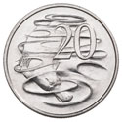
Method
- Hold the piece of card in one hand and the coin in the other, at the same height.
- Drop them both at the same time.

Observations
- Describe what happened to the card and the coin.

- What force(s) were acting on the card and the coin?

- Is the force(s) acting on the card and the coin a contact force or a non-contact force?

- Are the forces acting on the card and the coin balanced or unbalanced? Give a reason for your choice.

Part B
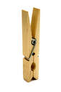
Materials

- 20 cent coin
- Wooden peg
- Small square of card

Method
- Stand the peg on one end and place the card on top of the peg. Balance the coin on the card.
- Holding the peg at the base, try to flick the card out from under the coin, keeping the coin balanced on top of the peg.

Observations
- Describe what happened to the coin, the card and the peg.

- What type of force acted on the card when you flicked it?

- Why could you flick the card out from under the coin and leave it on the peg?

- Are the forces acting on the card balanced or unbalanced? Give a reason for your choice.

- Are the forces acting on the coin balanced or unbalanced? Give a reason for your choice.
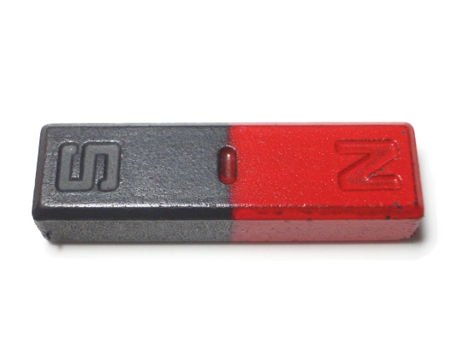
Part C
Materials
- 2 bar magnets with their poles marked

Method
- Hold one magnet in each hand with opposite poles facing towards each other.
- Slowly bring them closer together.
- Now, hold one magnet in each hand with the same poles facing towards each other.
- Slowly bring them closer together.

Observations
- What did you notice when the opposite poles of the magnet were facing towards each other?

- What did you notice when the same poles of the magnet were facing towards each other?

- What type of force is acting between the magnets?

- Is this force a contact or a non-contact force?

Part D
Materials

- Plastic pen
- Small pieces of paper

Method
- Rub the plastic pen quickly on your clothes.
- Bring the pen close to the pieces of paper.

Observations
- What happens when you bring the pen near the pieces of paper?

- The force here is due to an electrostatic charge on the pen. Does the pen need to be touching the paper or can the electric force act over a distance?
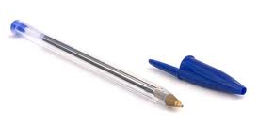

- Is an electrostatic force a contact or non-contact force?

Part E
Materials

- Table tennis ball
- Drinking straws

Method
- Gently roll the table tennis ball towards you.
- Use the straw to blow on the ball as it moves towards you.
- Record your observations below.
- Gently roll the table tennis ball away from you.
- Use the straw to blow on the ball as it moves away from you.
- Record your observations below.
- Gently roll the table tennis ball across the table in front of you.
- Use the straw to blow on the ball as it move in front of you.
- Record your observations below.

Observations
- Describe what happened when you blew on the table tennis ball while it moved towards you.

- Describe what happened when you blew on the table tennis ball while it moved away from you.

- Describe what happened when you blew on the table tennis ball while it moved across in front of you.

- Is this an example of a contact force or a non-contact force? Give a reason for your choice.

Extra for Early Finishers: Tabletop Soccer (2 or 4 players)
Materials

- Table tennis ball
- Drinking straws
- Blu-tack

Method
- Using the blu-tack, make two sets of goals by sticking three straws together in a U-shape.
- Blu-tack the goals to the desk at either end.
- Team members stand at either end of the desk and try to score a goal by blowing the table tennis ball across the table.

